**5**

Review the following graphics:   
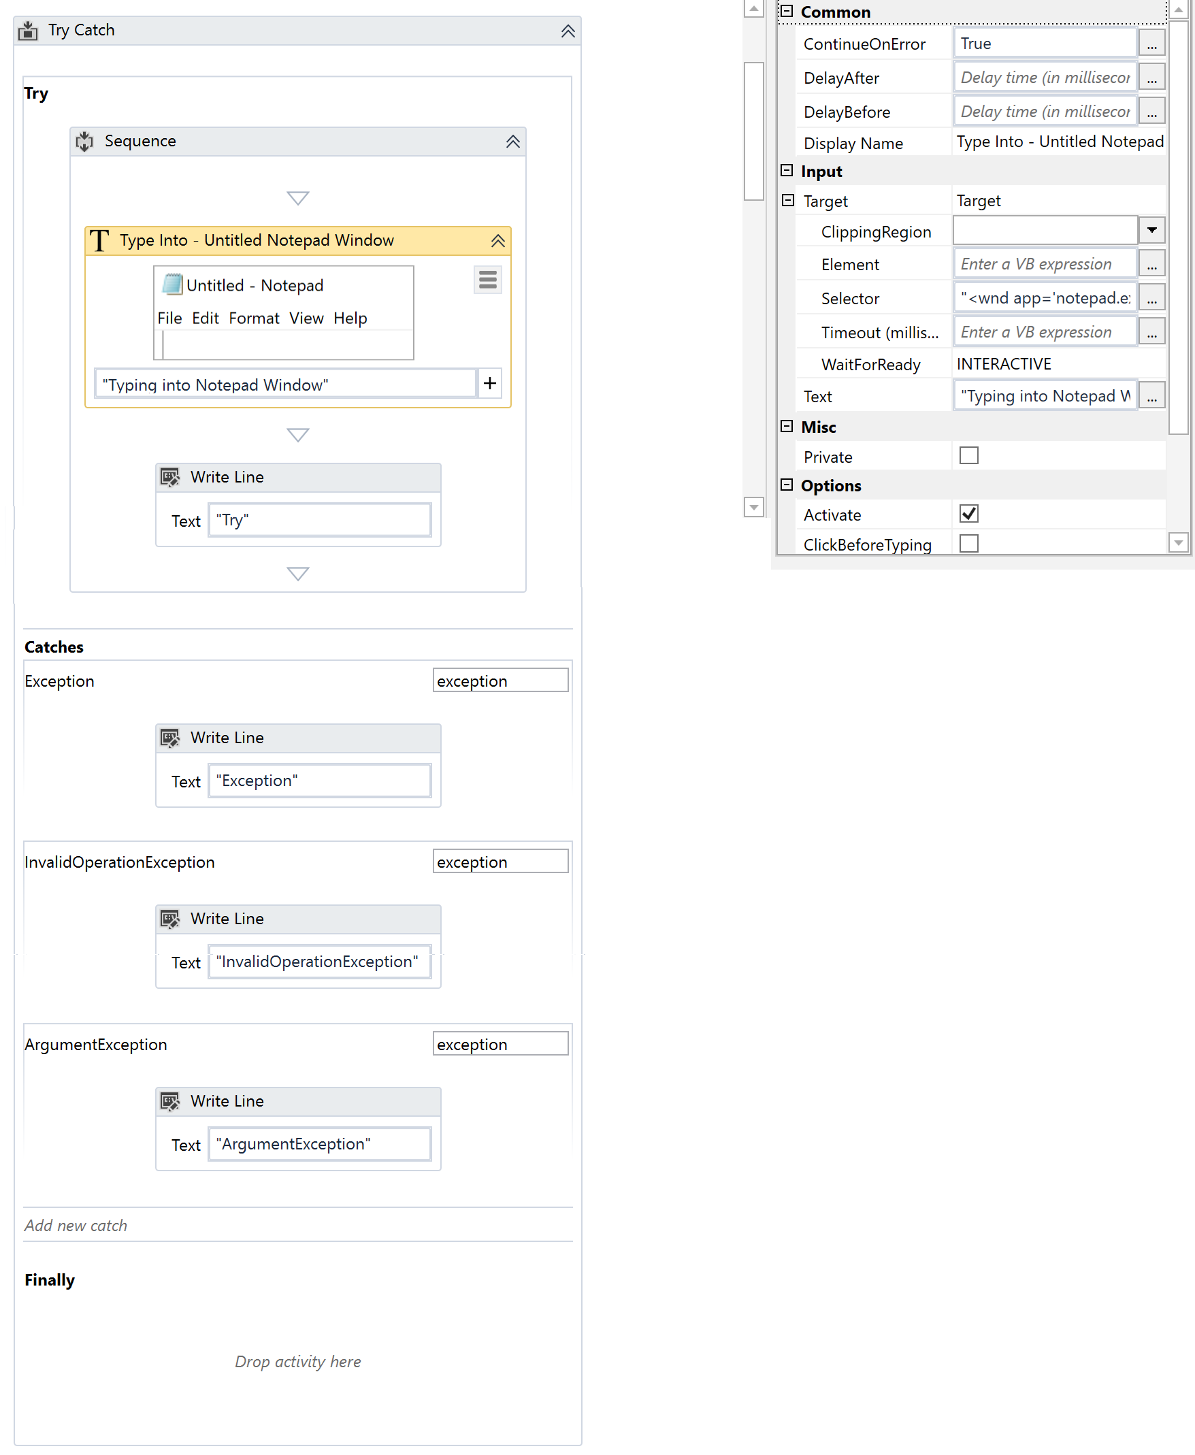 If the automation is executed and Notepad.exe is not running, which Write Line text value is contained in the Output panel?

Explanation

Topic: Identify and describe the use of the error handling activities such as Try Catch, Throw, Rethrow, and Retry Scope

**9**

When an Application-level Exception is encountered, which type of exception is caught in the Robotic Enterprise (RE) Framework by default?

Explanation

Topic: Differentiate between using Application Exceptions and Business Rule Exceptions

**10**

If you want to read a specific set of pages from a PDF file using the Extract PDF Page Range activity, what describes this activity?

Explanation

Topic: Identify and describe how activities are used to automate actions in Excel, e-mail, and .pdfs

**16**

A developer uses Workflow Analyzer to check the process shown in the following graphic:   
   
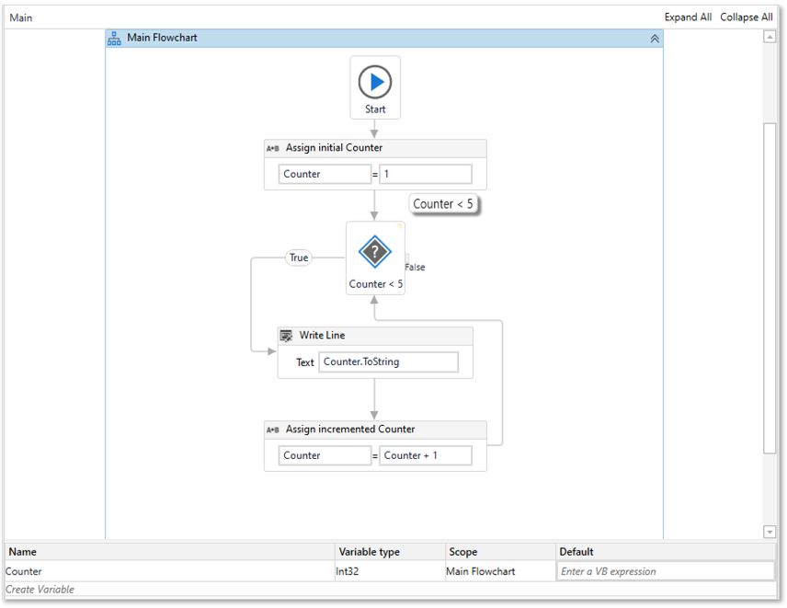  
   
If the Workflow Analyzer is configured with the default rules, which warning will be shown in the Error List?

Explanation

Topic: Describe the functionality of the Workflow Analyzer and how to create new rules

**17**

A Click activity with a partial selector is nested inside another activity. In which activity is the Click activity contained for the workflow to execute?

Explanation

Topic: Describe the differences between using full selectors versus using partial selectors

**23**

During testing, a process fails due to a timeout. The developer wants to know every activity the process completed while reviewing the logs in Orchestrator.  
  
To ensure the logs provide this descriptive information, which Logging Level must be set?

Explanation

Topic: Describe how to write coherent log messages (default or user-defined), and how to use them to diagnose and debug a production process running in UiPath Studio

**24**

You added six Queue Items to your queue on 11/14/2020. What is the correct sequence in which these Queue Items will be processed?  
  
**Instructions:** From the drop-down list, select the correct number in which the Queue Items are processed.

Explanation

Topic: Describe how to work with Orchestrator queues and assets

**25**

A developer has created a process that gathers a listing of tickets and their associated details. Using regular expressions, the listing is filtered to retrieve the IDs of all tickets raised for a specific application (APP3). The listing of tickets is retrieved as a String variable and the format of the Ticket IDs is **<ApplicationName>-<TicketNumber>**, where **<ApplicationName>**is**APP3** and the **<TicketNumber>** represents a newly added ticket number.  
  
During testing, the developer notices that the Ticket IDs are correctly identified only if the **<TicketNumber>** has exactly 2-digits.   
  
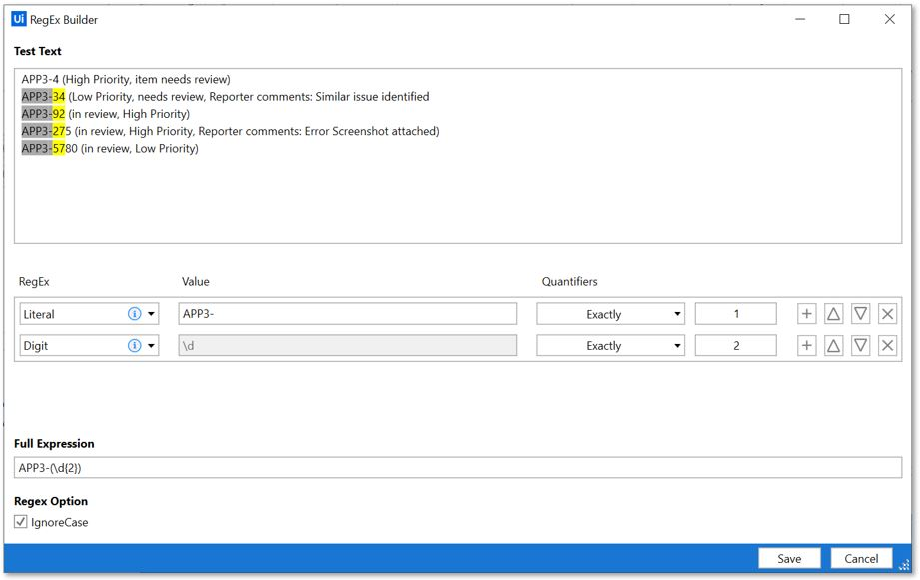  
  
How should the second line of the expression shown in the graphic referenced above be modified to ensure that all valid ticket numbers are identified, regardless of how many new tickets are added?

Explanation

Topic: Identify and describe how string manipulation, regular expressions, and string methods are used

**27**

A developer implemented a Dispatcher process using the Robotic Enterprise (RE) Framework to upload items to a queue. Each Queue Item contains an ID of a ticket created by an employee assigned to a department. The Performer runs 24/7 and processes these Queue Items.  
  
The business requirement is that the tickets should have a deadline set at the Queue Item level. Each department has a different Service Level Agreement (SLA) specified in the process documentation. The Sales department requires their tickets to be processed within one hour.   
  
What is the correct expression that should be added in the "Deadline" property in the Add Queue Item activity for the Sales department?

Explanation

Topic: Describe the differences between Dispatcher and Performer. Describe how Dispatcher is used to upload transaction processes and how Performer is used to consume the queues and process the transactions.

**28**

You are working with an application that allows all types of input methods for the Type Into activity. Which property should be enabled for the fastest execution?

Explanation

Topic: Differentiate between using Simulate versus Send Windows Message versus Default

**29**

After finishing development, a developer observes in UAT that a selector corresponding to a UI element within an application changed. This breaks the automation and the automation fails to execute as expected.  
  
Based on UiPath recommendations, what is the correct sequence of steps the developer should take to debug the error and remedy the issue?  
  
**Instructions:** From the drop-down list, select the correct number in which the step should occur.

Explanation

Topic: Examine and describe the activities and/or features used to troubleshoot, debug, and modify processes

**38**

A developer decided to create a process using a state machine. What is the correct execution sequence of the parts in the State activity?  
  
**Instructions:** From the drop-down list, select the correct number in which each execution sequence occurs.

Explanation

Topic: Describe how to use state machines versus flowcharts and sequences

**42**

A developer plans to create a repetitive process in the Robotic Enterprise (RE) Framework. Based on best practices, which action(s) should be followed to defend against potential robot crashes such as out of memory?

Explanation

Topic: Modify the REFramework to use any datatype for TransactionItem (for example, QueueItem, String, DataTable, etc.) and describe how queues and tabular data are used within the REFramework

**48**

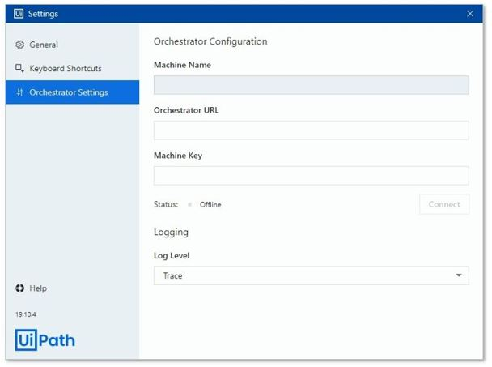  
  
Based on the graphic, logs of which level will be sent to Orchestrator during process execution when Orchestrator is connected?

Explanation

Topic: Describe how to write coherent log messages (default or user-defined), and how to use them to diagnose and debug a production process running in UiPath Studio